UXP-jQuery-L2-0002: Search Table List

Level: L2

Technologies: jQuery, HTML5, Css3, Bootstrap**.**

Case Study: To Create Search Table List

**Tips to start**

**Case Study – jQuery Search table list**

Visual:

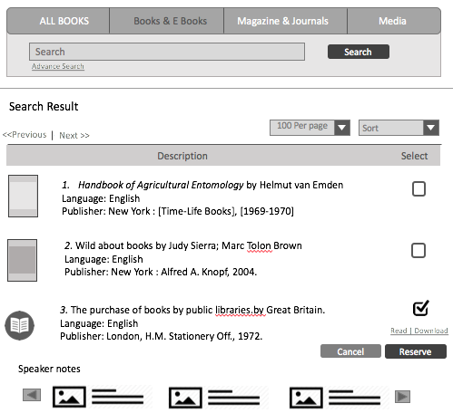

**Getting Started:**

Bootstrap your HTML page, create a HTML5 page with CSS3 and jQuery.

**Dependencies:**

develop html page using bootstrap framework and for sorting and pagination use jQuery. Refer the links below.

Bootstrap: <http://getbootstrap.com/>

jQuery library: https://jquery.com/download/

**Additional notes:**

* Create a table in HTML5.
* In the above table add a column “Type of book”, and make it sortable.
* User should have the option to select the number of items to be displayed.
* Pagination also can be included.